**Industry Internship Project   
2016 – 18 Batch**

**Title of the Project:**

Study of Consumer Perspective and Developing Innovative Marketing Strategies for Birla Sun Life Insurance



***Submitted by:***

**Name of the Student : Annu Choudhary**

Roll No. : PGDM16181041

Program : PGDM

Batch : M1

**Name of the Faculty Guide : Dr. Deepa Nair**

**Name of the Company : Birla Sunlife Insurance**

**Name of the Company Guide : Mr. Nilay Shah**

**Company Guide Designation : Associate Partner**

**Institute for Technology and Management  
Plot No. 25 / 26, Institutional Area,  
Sector – 4, Kharghar, Navi Mumbai**

**Declaration**

I, Ms. Annu Choudhary, studying in the second year of PGDM at ITM Business School, Kharghar, Navi Mumbai, hereby declare that I have completed the Summer Internship Project titled “Study of Consumer Perspective and Developing Innovative Marketing Strategies for Birla Sun Life Insurance” as a part of the curriculum requirement for course name.

I also declare that the work undertaken by me is original and has not been copied from any source. I further declare that the information presented in this project report is true and has not been submitted to ITM or any other Institute for any other examination.

Signature of the Student Date:

Name of the Student: Annu Choudhary

Roll No.: PGDM16181041

**Acknowledgement**

I hereby wish to express my gratitude to my guide of Birla Sun life insurance Mr. Nilay Shah for providing me with immense knowledge in insurance sector.

I am thankful to ITM Business School for giving me the opportunity to do my internship in Birla Sun life. I wish to thank our marketing HOD Mrs. Prachi Gupta who has been the source for inspiration and help us to improve our practical knowledge.

I am also grateful to my coordinator Dr. Deepa Nair for the immense support guidance and encouragement throughout the internship studies.

I would like to express my thanks to various people who helped me directly and indirectly to carry out my project in a positive manner.

Signature

Annu Choudhary

Date:

Table of Contents

[Executive Summary 6](#_Toc493148140)

[CHAPTER 1 7](#_Toc493148141)

[INTRODUCTION 7](#_Toc493148142)

[1.1.PROBLEM ON HAND 8](#_Toc493148143)

[1.2.Sales 8](#_Toc493148144)

[1.3 OBJECTIVES 9](#_Toc493148145)

[1.4 SCOPE OF THE PROJECT 10](#_Toc493148151)

[1.5. Purpose and Significance of the Project 10](#_Toc493148156)

[LITERATURE REVIEW 10](#_Toc493148161)

[CHAPTER 2: DETAILS OF THE ORGANISATION 13](#_Toc493148162)

[2.1 INTRODUCTION 13](#_Toc493148163)

[2.2 BACKGROUND OF THE PROJECT 14](#_Toc493148164)

[INSURANCE 14](#_Toc493148165)

[HISTORY OF INSURANCE 15](#_Toc493148166)

[INDIAN INSURANCE MARKET 17](#_Toc493148167)

[TYPES OF INSURANCE 18](#_Toc493148168)

[TYPES OF LIFE INSURANCE IN INDIA 20](#_Toc493148169)

[MECHANISM OF LIFE INSURANCE 21](#_Toc493148173)

[PORTER’S 5 FORCE MODEL OF INSURANCE INDUSTRY 22](#_Toc493148175)

[PRODUCTS OF BIRLA SUN LIFE INSURANCE 24](#_Toc493148176)

[SWOT ANALYSIS 28](#_Toc493148207)

[MISSION, VISION & CORE VALUES 30](#_Toc493148231)

[CHAPTER 3: TASKS PERFORMED 32](#_Toc493148232)

[3.1 Research methodology 32](#_Toc493148233)

[3.2 Objectives and Design 34](#_Toc493148244)

[3.3Primary /Secondary 34](#_Toc493148255)

[DATA ANALYSIS 45](#_Toc493148371)

[CHAPTER 4: CONCLUSION 52](#_Toc493148390)

[4.1 Summary 52](#_Toc493148391)

[4.2 Gains Of The Study 52](#_Toc493148395)

[4.3 Limitations of the Project 52](#_Toc493148396)

[Chapter 5: RECOMMENDATIONS 53](#_Toc493148399)

[REFERENCES 55](#_Toc493148400)

**Executive Summary**

Birla Sun Life Insurance company Ltd. is a joint venture between the Indian conglomerate Aditya Birla Group, and Sun Life Financial Inc. an international financial services organizations from Canada. BSLI has a customer base of over two and half million policy holders. It was founded in the year 2000 and is headquartered in Elphinstone Road, Mumbai. Mr. Kumar Mangalam Birla is the chairman and Mr. Pankaj Razdan is the MD & CEO of the company. The duration of the project was three months(17April-July 2017).

Life is full of risks and uncertainties. Since we are social human beings, we have certain responsibilities too. Indian consumers have big influence of emotions and rationality on their buying decisions. They believe in future rather than present and desire to have a better and secured future. In this direction life insurance services have its own value in terms of minimizing risk and uncertainties. Indian economy is developing and having huge middle class societal status and salaried individuals.

Analyzing consumer behavior is perceived as cornerstone of a successful media and marketing strategy. Consumer behavior is a mental and emotional process and the observable behavior of consumers during searching, purchasing and post consumption of a product and service. Similarly consumer behavior is action and decision process of people who purchase goods and services for personal consumption. Now if these defining criteria are closely observed, it is evident that analyzing consumer’s decision-making process is the foundation of entire notion of consumer behavior.

The following report gives an overview of

* Designing innovative and interactive marketing plan and strategies for a product of Birla Sun Life i.e. Birla Life Insurance Vision Life Income plan.
* Portraying my contribution on Media Planning & Advertising strategies and implementing the same through various media platforms (TVC, print media, hoardings, etc.).
* In addition to this, the report mentions an annual marketing plan which is strategized& will probably be implemented in future to enhance the online and offline presence of Birla Sun Life.

# 

# ssli.jpg

# CHAPTER 1

# INTRODUCTION

**BIRLA SUN LIFE INSURANCE**

Birla Sun Life Insurance Company Limited (BSLI) is a joint venture between the Aditya Birla Group and Sun Life Financial Inc., a leading international financial services organization. It was founded in the year 2000. The company is based in Mumbai, India. The local knowledge of the Aditya Birla Group combined with the expertise of Sun Life Financial Inc., offers a value proposition to customers. Sun Life Financial and its partners today have operations in key markets worldwide, including India, Canada, the United States, the United Kingdom, Hong Kong, Philippines, Japan, Indonesia, China and Bermuda.

Sun Life Financial Inc. is a leading performer in the life insurance market in Canada. BSLI in its seventeen successful years of operations has contributed significantly to the growth and development of the life insurance industry in India. It pioneered the launch of Unit Linked Life Insurance plans amongst the private players in India. It was the first player in the industry to sell its policies through the Bank assurance route and through the internet. In April 2016, Sun Life Financial increased their stake in Birla Sun Life Insurance to 49%.

BSLI has a customer base of over two and half million policy holders and has attained recognition as the 3rd Most Trusted Life Insurance Company in the 'Most Trusted Brands' survey 2013 conducted by Brand Equity with Neilsen. The company offers a range of insurance services comprising protection solutions, children's future solutions, savings with protection solutions, wealth with protection solutions, health and wellness solutions, and retirement solutions.The company also provides rural insurance and Non-resident Indian solutions, and management service of pension funds. BSLI carries out its community projects and programmes under the aegis of The Aditya Birla Centre for Community Initiatives and Rural Development, founded in 1997.It has a distribution reach in over 500 cities through its network of over 550 branches, more than 1,05,000 empaneled advisors and over 100 partnerships with corporate agents, brokers and banks.

## 1.1.PROBLEM ON HAND

* To do each quarters planning for promotion of Birla sun life through online and offline media.
* To find the consumer’s perspective for each promotional strategy

## 1.2.Sales

* To sell the product called vision life income worth of 50K.

## 1.3 OBJECTIVES

### To study and analyze the Insurance industry in India.

### To determine and analyze the market potential of Life Insurance sector in India.

### To study and determine the competitor position of Birla Sun Life Insurance in the market.

### To understand the marketing strategies adopted by Birla Sun Life Insurance Company Ltd. to promote its brand and products.

### To know the customer awareness regarding the Birla-sun life insurance and its product

**Process of tasks/targets assigned: -**

* Making day to day plan for each activity
* Selecting appropriate media channel
* Doing online and offline promotions
* Making print media ads, posters, hoardings, billboards etc.
* Finding Exact cost of media channels for each month
* Estimating revenue from advertising
* Called and convinced the customer to take the policies.
* Prepared the questionnaire for each quarter.
* Took survey from the respondents
* Recorded the response of the respondents in the excel sheet

## 1.4 SCOPE OF THE PROJECT

### To study the customer perception regarding Birla Sun Life Insurance Company.

### The target group of Birla Sun Life Insurance is upper middle and high-class customers. The scope of this project is to increase awareness among the middle and lower income people as well.

### There are customer growth prospects in many untapped rural areas.

### The marketing campaigns are not that effective as compared to its competitors, so more brand awareness activities should be carried out to capture a larger market.

## 

## 1.5. Purpose and Significance of the Project

### The primary purpose of this project is to strengthen the company’s marketing strategies in the stipulated time of two months.

### Creating awareness of the brand “Birla Sun Life Insurance”

### Preparing quarterly marketing plans for the products by making them more interactive and innovative to increase the customer base.

### Resolving customer queries by bridging the gap between customer expectations and the actual product.

### LITERATURE REVIEW

**Selvavinayagam, K. and Mathivanan, R. (2010)**This review has revealed that the competitive climate in the Indian insurance market has changed dramatically over the last few years. At the same time, changes have been taking place in the Government regulations and technology. The expectations of policyholders are also changing. The existing insurance companies have to introduce many new products in the market, which have competitive advantage over the products of life insurance companies

**Ramanathan, K.V. (2011)**This study has resulted in the development of a reliable and valid instrument for assessing customer perceived service quality, awareness level, and satisfaction level of customers towards life insurance industry. Here, service quality needs to be measured using a six dimensional hierarchal structure consisting of assurance, competence, personalized financial planning, corporate image and technology dimensions. This would help the service managers to efficiently allocate resources, by focusing on important dimensions first. There is no right and wrong in this. The success of marketing insurance depends on understanding the social and cultural needs of the target population, and matching the market segment with the suitable intermediary segment.

**Chaudhary (2012)**Has explained that today India is one of the fastest growing economies of the world. The Insurance Industry contributes to the financial sector of an economy and provides social security to the people of a country. The income earning capacity and increasing rate of literacy are the key factors of the growth of the Insurance industry. This sector provides for the long term contractual savings and security. The investors in life insurance are looking for both good return and life risk coverage.

**Tiwari and Yadav (2013**) Has determined that the deregulation of the Indian Insurance market, low insurance market penetration and the anticipated potential of the Indian insurance industry make it an attractive opportunity for private Entrants. With the progress of IRDA reforms and enactment of IRDA act 1999, liberalization of the insurance market in India gave entry to many private insurers, resulting in drastic changes in respect to people’s choice of companies. With the Expansion of the market, insurance penetration and density of the country has been improved, leading to a competition within the companies in terms of policies Sold, collection of premium income, first premium income, market share,

Settlement of claims and others. In India life insurance is regarded as more than a Mere risk cover and is considered an important avenue of investment. Indian Investors therefore, evaluate the past track record and risk potential of an Insurer Before taking a policy investment decision

**Rao (2014)**states that liberalization of the financial services sector has led to insurance companies functioning increasingly under competitive pressures, so companies are consequently directing their strategies towards increasing customer satisfaction and loyalty through improved service quality.

With the opening of insurance industry to private players, the competition has Intensified and it has become very difficult for the companies to attract and retain the policyholders. Every company has recognized the need for shifting from a traditional strategy to survive in the market. It is in this context, the process of CRM has been adopted by all private and public-sector insurance companies as well. CRM technologies and campaign management tools are maturing and finding wider adoption with large insurance companies.

# 

# CHAPTER 2: DETAILS OF THE ORGANISATION

## 2.1 INTRODUCTION

**About The Aditya Birla Group**

Named after Aditya Vikram Birla and headquartered in the Aditya Birla Centre in Wolli, Mumbai, the company operates in 40 countries with more than 120,000 employees worldwide, seven lakh shareholders & a market capitalization of Rs.53,400 crore. It is one of the largest business houses in India. It enjoys a leadership position in all the sectors such as viscose staple fiber, metals, cement, branded apparel, carbon black, chemicals, fertilizers, insulators, financial services, telecom, BPO and IT services. The group has a revenue of approximately US$41 billion. With over 75 business units spanning the South East Asian belt, Africa, Canada and the UK among others, it is reckoned as India's first multinational corporation.

**About Sun Life Financial Inc.**

It is a leading international financial services organization providing adverse range of wealth accumulation and protection products and services to individuals and corporate customers. Having its roots back to 1865, Sun Life Financial and its partners today have operations in remarkets worldwide, including Canada, the United States, the United Kingdom, Hong Kong, the Philippines, Japan, Indonesia, India, China and Bermuda. Sun Life Financial Inc. has the total assets under management of $891 billion. Sun Life Financial Inc. trades on the Toronto (TSX), New York (NYSE) and Philippine (PSE) stock exchanges under ticker symbol "SLF".

**Competitors**: -

* Life insurance corporation
* SBI life insurance
* MetLife insurance
* HDFC life insurance
* Bharathi Axa life insurance
* Bajaj Allianz life insurance
* Tata AIG life insurance
* ICICI Prudential Life Insurance

## 1.2 BACKGROUND OF THE PROJECT

This project is a study about the insurance industry and how it is perceived by the people. Talking about insurance , the evolution of insurance dates back as early as the commencement of trade between two countries where during the transportation of goods, there were chances of the ship being drowned in the sea , attacked by the pirates or goods catching fire, leading to huge loss to the party sending goods. The traders devised away whereby the loss of the goods would be compensated by every trader putting in some amount as per their financial strength so that a single party may not be at loss , this is the earlier concept of insurance. In India the first insurance company was established in 1818 and the name of the company was oriental life insurance company.

### INSURANCE

Insurance is a contract between two parties where one party promises to make good the loss suffered by the other party caused either by the promisor or any other person. It is a protection from financial loss. The party providing the insurance is known as an insurer, insurance company, or insurance carrier. A person who buys insurance is known as an insured or policyholder. People, who are in similar trade and are exposed to the same risks, congregate and some to an agreement that if any individual member suffers a loss, then the loss will be shared by others and minimized in order to enable the individual member recover from the loss and cover his ground. Similarly the different kinds of risks can be identified and separate groups can be formed to counter such risks and reduce to impact to manageable proportion, in which the share could be collected from the members either after the loss or in advance, at the time of admission to the group. Insurance extends not only to tangible assets but also to intangible assets. In some countries even the voice of a singer, legs of the footballer can be insured.

**HISTORY OF INSURANCE**

Turning to insurance in the modern sense (i.e., insurance in a modern money economy, in which insurance is part of the financial sphere), early methods of transferring or distributing risk were practiced by the Chinese and the Babylonian traders as long as the 3rd and 2nd millennia BC, respectively. Chinese merchants travelling treacherous river rapids would redistribute their wares across many vessels to limit the loss due to any single vessel’s capsizing.

Monarchs of Iran were the first to insure their people and made it official by registering the insuring process in governmental notary offices. The insurance tradition was performed in the beginning of the Iranian New Year, the heads of the different ethnic groups as well as others willing to take part, presented gifts to the monarch. The most important gift was presented during a special ceremony. When a gift was worth more than 10,000 Derrik (gold coin), the issue was registered in a special office. This was advantageous to those who presented such special gifts. For others, the presents were fairly assessed by the confidants of the courts. Then the assessments were registered in special offices.

A thousand years later, the inhabitants of Rhodes invented the concept of the ‘general average’. Merchants whose goods were being shipped together would pay a proportionally divided premium which would be used to reimburse any merchant whose goods were jettisoned during storm or sinkage.

Towards the end of the seventeenth century, London’s growing importance as a centre of trade increased demand for marine insurance. In the late 1680s, Edward Lloyd opened a coffee house that became popular haunt of ship owners, merchants, and ships’ captains, and thereby a reliable source of the latest shipping news.

It became the meeting place for parties wishing to insure cargoes and ships, and those willing to underwrite such ventures.

Today, Lloyd’s of London remains the leading market (note that it is not an important insurance company) for marine and other specialist types of insurance, but it works rather differently than the more familiar kinds of insurance.

Insurance as we know today can be traced to the Great Fire of London*,* which in 1666 devoured 13,200 houses. In the aftermath of this disaster, Nicholas Barbon opened an office to insure buildings. In1680, he established England’s first fire insurance company, “The Fire Office”, to insure brick and frame homes.

The first insurance company in the United States underwrote fire insurance and was formed in Charles Town (modern-day Charleston), South Carolina, in 1732.

Benjamin Franklin helped to popularize and make standard the practice of insurance, particularly against fire in the form of perpetual insurance. In 1752, he founded the Philadelphia Contribution ship for the Insurance of Houses from Loss by Fire. Not only did his company warn against certain fire hazards, it refused to insure buildings where the risk of fire was too great, such as all wooden houses.

### INDIAN INSURANCE MARKET

Insurance industry plays a vital role in the Indian market. There are altogether 53 insurance companies that are serving both life insurance and general insurance products to the customers countrywide.

The life insurance sector recorded a new premium income of Rs. 1.38 trillion in a year, i.e. April 2015 to March 2016. This indicated a dramatic growth rate of 22.5% in the premium income, whereas the general insurance sector centered on [**two-wheeler insurance policy**](https://www.policybazaar.com/motor-insurance/two-wheeler-insurance/) (particularly) recorded a 12% of growth by receiving a premium income of Rs. 105.25 billion during the year, i.e. April 2016 to March 2017. The life insurance sector offers about 360 million policies, which count to be the largest in the world. Still, it is expected to cross compound annual growth rate of 12 to 15% in the next 5 years. It is expected that the Indian insurance market will quadruple in size over the next 10 years and the life insurance sector is expected to collect more than US $160 billion. There are a lot of opportunities in the Indian insurance market. Currently, the general insurance business in the Indian market accounts for more than Rs. 70,000 Crore premiums yearly, and it is growing at a positive rate of 17% every year.  
Despite being the second highly populous country in the world, Indian insurance market accounts for less than 1.5% of the world’s total insurance premium.

**Development in Indian Insurance Market**

1. The Insurance Regulatory and Development Authority of India (IRDA) has designed public offering guidelines for insurance providers in India, which regulated the divest equity through the IPO route.
2. The best development in the Indian insurance market is Lloyd’s – a UK-based insurance company entering the Indian market in 2017, after the approval of Insurance Regulatory and Development Authority of India (IRDA).
3. It has been announced by the State Bank of India that Paribas Cardif is planning to revise its stake in SBI Life Insurance from 26% to 36%. Once the stake increases by foreign joint venture, SBI’S stake in SBI Life will get merged with 64%.
4. The government has also designed two insurance schemes :

– Pradhan Mantri Suraksha Bima Yojana, which is a Personal Accident Insurance plan

– Pradhan Mantri Jeevan Jyoti Bima Yojana, which is the government’s Life Insurance plan.

1. IRDA has formulated a regulation, which imposes obligations on insurance providers towards offering insurance coverage to the rural and financially weaker sections of the societies in India

### TYPES OF INSURANCE

Any risk that can be quantified can potentially be insured. Specific kinds of risk that may give rise to claims are known as “perils”. An insurance policy will set out in detail which perils are covered by the policy and which is not. Below is a list of the many different types of insurance that exist. A single policy may cover risk in one or more of the categories set out below. For example, vehicle insurance would typically cover both property risk (covering the risk of theft or damage to the car) and liability risk (covering legal claims from causing an accident.

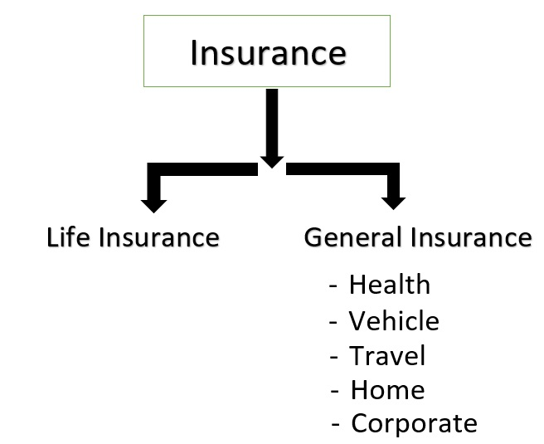

#### General insurance

Any insurance that is not determined to be life insurance. Types of general insurance include health, motor, travel, home, marine, commercial insurance.

All these are non-life insurance. One can safely say that the purpose of insurance be it non-life is to transfer the financial loss to the insurance company who spreads in over to the policyholders.

#### Life insurance

Life insurance provides a monetary benefit to a decedent’s family or other designated beneficiary, and may specifically provide for income to an insured person’s family. Life insurance policies often allow the option of having the proceeds paid to the beneficiary either in a lump sum cash payment or an annuity. Annuities provide a stream of payments and are generally classified as insurance because they are issued by insurance companies and regulated as insurance and require the same kinds of actuarial and investment management expertise that life insurance requires. Annuities and pensions that pay a benefit for life are sometimes regarded as insurance against the possibility that a retiree will outlive his or her financial resources. In that sense, they are the complement of life insurance and, from an underwriting perspective, are the mirror image of life insurance. It is one of the fastest growing sector in India since 2000 as Government allowed Private players and FDI up to 26% and recently Cabinet approved a proposal to increase it to 49%. Life Insurance in India was nationalized by incorporating Life Insurance Corporation (LIC) in 1956. All private life insurance companies at that time were taken over by LIC.

### TYPES OF LIFE INSURANCE IN INDIA

1. TERM INSURANCE PLAN- The basic premise of a term insurance policy is to secure the immediate needs of beneficiaries in the event of sudden or unfortunate demise of the policy holder. The policy holder does not get any monetary benefit at the end of the policy term except for the tax benefits he or she can choose to avail of throughout the tenure of the policy. In the event of death of the policy holder, the sum assured is paid to his or her beneficiaries. Term insurance policies are also relatively cheaper to acquire as compared to other insurance products
2. WHOLE LIFE POLICIES – This plan covers the insured over his life. The primary feature of this product is that the validity of the policy is not defined so the policyholder enjoys the life cover throughout his life.
3. MONEY BACK POLICIES - Money back policies are basically an extension of endowment plans wherein the policy holder receives a fixed amount at specific intervals throughout the duration of the policy. In the event of the unfortunate death of the policy holder, the full sum assured is paid to the beneficiaries. The terms again might slightly vary from one insurance company to another.
4. UNIT-LINKED INVESTMENT POLICIES (ULIP) - Unit linked insurance policies again belong to the insurance-cum-investment category where one gets to enjoy the benefits of both insurance and investment. While a part of the monthly premium pay-out goes towards the insurance cover, the remaining money is invested in various types of funds that invest in debt and equity instruments. ULIP plans are more or less similar in comparison to mutual funds except for the difference that ULIPs offer the additional benefit of insurance

### 

### MECHANISM OF LIFE INSURANCE

There are two parties involved in an insurance contract i.e. an Insurer and the insured. Another important person involved is the beneficiary who will receive the policy proceeds upon the death of the insured. The policy is a legal contract specifying the terms and conditions of the risk assumed. The face amount of the policy is normally the amount paid when the policy matures, although policies can provide for greater or lesser amounts. The policy matures when the insured dies or reaches a specified age. The most common reason to buy to buy a life insurance policy is to protect the financial interests of the owner of the policy in case of the insured’s death. Other reasons reason includes estate planning and retirement. Upon the death of the insured, the insurer will require acceptable proof of death before paying the claim. The normal minimum proof is a death certificate and the insurer's claim form completed and signed. If the insured's death was suspicious and the policy amount warrants it, the insurer may investigate the circumstances surrounding the death, before deciding whether there is a legal obligation to pay the claim. Proceeds from the policy may be paid in a lump sum or as an annuity paid over time in regular recurring payments for either for the life of a specified person or a specified time.

## PORTER’S 5 FORCE MODEL OF INSURANCE INDUSTRY

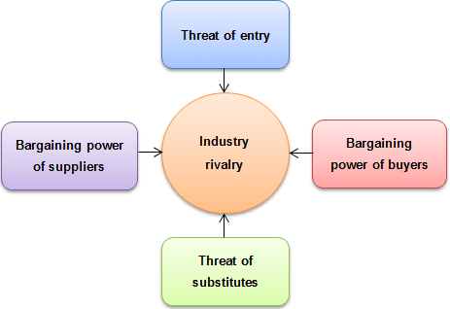

1. **Threat of New Entrants**- The average entrepreneur can't come along and start a large insurance company. The threat of new entrants lies within the insurance industry itself. Some companies have carved out niche areas in which they underwrite insurance. These insurance companies are fearful of being squeezed out by the big players. Another threat for many insurance companies is other financial services companies entering the market.
2. **Power of Suppliers**. The suppliers of capital might not pose a big threat, but the threat of suppliers luring away human capital does. If a talented insurance underwriter is working for a smaller insurance company (or one in a niche industry), there is the chance that person will be enticed away by larger companies looking to move into a particular market
3. **Power of Buyers**. The individual doesn't pose much of a threat to the insurance industry. Large corporate clients have a lot more bargaining power with insurance companies. Large corporate clients like airlines and pharmaceutical companies pay millions of dollars a year in premiums. Insurance companies try extremely hard to get high-margin corporate clients.
4. **Availability of Substitutes**. There are plenty of substitutes in the insurance industry. Most large insurance companies offer similar suites of services. Whether it is auto, home, commercial, health or life insurance, chances are there are competitors that can offer similar services. In some areas of insurance, however, the availability of substitutes are few and far between. Companies focusing on niche areas usually have a competitive advantage, but this advantage depends entirely on the size of the niche and on whether there are any barriers preventing other firms from entering
5. **Market Rivalry**. The insurance industry is becoming highly competitive. The difference between one insurance company and another is usually not that great. As a result, insurance has become more like a commodity - an area in which the insurance company with the low cost structure, greater efficiency and better customer service will beat out competitors. Insurance companies also use higher investment returns and a variety of insurance investment products to try to lure in customers. Larger companies prefer to take over or merge with other companies rather than spend the money to market and advertise to people.

## PRODUCTS OF BIRLA SUN LIFE INSURANCE

Life is unpredictable and full of risks. We have our responsibilities towards our parents, children and loved ones which cannot be compromised at any cost. Insurance planning helps us to smooth out the uncertainties and unexpected adversities of life.   
BSLI offers the following insurance solutions:

1. Protection plans
2. Retirement plans
3. Health & wellness
4. Savings and protection
5. Children’s future
6. Wealth with protection

Insurance can be further divided as:

### VISION LIFEINCOME PLAN – Child, Wealth, Retirement solutions

### FEATURES

### Age bracket – 1 to 60 years

### Policy term – Whole life to Age 100

### Premium paying term – 20 years

### Premium- [Indian Rupee symbol.svg](https://en.wikipedia.org/wiki/File:Indian_Rupee_symbol.svg) 50,000

### Premium frequency – Annual, semi- Annual, quarterly, monthly

### Sum invested - [Indian Rupee symbol.svg](https://en.wikipedia.org/wiki/File:Indian_Rupee_symbol.svg)10, 00,000 (approx)

### Sum assured - [Indian Rupee symbol.svg](https://en.wikipedia.org/wiki/File:Indian_Rupee_symbol.svg) 8, 00,000 (approx)

### From the 20th year, [Indian Rupee symbol.svg](https://en.wikipedia.org/wiki/File:Indian_Rupee_symbol.svg)80,000 (approx) to be given on pro rata basis.

### Benefits

### Rider –These are the benefits that value to the chosen plan. In case of sudden death, disability, accident of the policy holder, this feature ensures that he is entitled to the rider sum assured benefit to cover up for his loss.

### WOP rider – WOP stands for Waiver Of Premium. This is mostly seen in child insurance policy as this primarily has been set up in place to provide money for your child in the hour of his/ her need. In these policies, where you are ensuring your child receives a sum of money at a certain pre-defined age, this will ensure that the process is uninterrupted and premium payment is continued even if the policy holder dies.

### Tax benefits - The premium paid qualifies for tax deduction under section 80C, 80D and Section 10(10D) of the Income Tax Act, 1961

### 

### Surrender benefits

### birla-sun-life-vision-plan-sample-benefits.gif

### smamsmasma.jpgVision-LifeIncome-Banner-Pg.jpg

### STP OF BIRLA SUN LIFE INSURANCE

### STP is Segmentation, Targeting and Positioning (STP) is a familiar strategic approach in Modern Marketing. It is one of the most commonly applied marketing models in practice. This model is useful when creating marketing communications plans since it helps marketers to prioritize propositions and then develop and deliver personalized and relevant messages to engage with different audiences. It helps us to analyze our product, its price and how we communicate its benefits to the mass and also to help position it more efficiently.

### SEGMENTATION - Personal and Group Asset Management

### TARGET GROUP – Urban and Rural investors

**POSITIONINING** - Complete Insurance and financial solutions

## SWOT ANALYSIS

### SWOT stands for:

### S- STRENGTHS

### W-WEAKNESSES

### O- OPPORTUNITIES

### T – THREATS

### It is a structured planning method that evaluates those four elements of an organization, project or business venture. A SWOT analysis can be carried out for a company, product, place, industry, or person. It involves specifying the objective of the business venture or project and identifying the internal and external factors that are favorable and unfavorable to achieve that objective.

### 

### SWOT ANALYSIS OF BIRLA SUN LIFE INSURANCE COMPANY LTD.

### STRENGTHS

* Has Network of 600 branches and advisors spread over 1500 towns in India having over 130,000 advisors
* Backed By Aditya Birla Brand and Sun Life financial services
* Emphasis on Customer Satisfaction through Transparent Functioning
* Strong Capital Base

WEAKNESSES

### Low Presence in Rural Market.

### Lesser advertising as compared to competitors.

### There is no plan for low income people.

### Fees of the advisor is high as compared to other companies.

### OPPORTUNITIES

### Growing potential in the Rural Market.

### Alignment with Government Schemes.

### Better awareness amongst people for getting insurance.

### It has many ULIP plans which has the potential to grow in future.

### THREATS

### Economic crisis and economic instability.

### Entry of new NBFCs in the sector.

### Competition from LIC,SBI LIFE INSURANCE AND HDFC STANDARD LIFE.

### Dominance of public sector insurance companies.

## MISSION, VISION & CORE VALUES

Birla Sun Life Insurance has established itself as one of the key players in the Indian Insurance industry. Our basic purpose is to ensure that customers have the financial wherewithal to meet future expenses of their children. As a responsible corporate citizen, “Integrity” is an integral part of our strategy. We aspire to be the leading insurance company by offering best child insurance solutions.

**OUR MISSION**

To delight our customer by providing quality insurance solutions.

**OUR VISION**

BIRLA SUN LIFE INSURANCE: To be the most preferred brand in the insurance segment.

**OUR VALUES**

The BIRLA Group has always sought to be a value-driven organization. These values continue to direct the Group's growth and businesses. The five core BIRLA values underpinning the way we do business are:

**Integrity:** Acting and taking decisions in a manner that is fair and honest. Following the highest standards of professionalism and being recognized for doing so. Integrity for us means not only financial and intellectual integrity, but encompasses all other forms as are generally understood.

**Commitment:** On the foundation of Integrity, doing all that is needed to deliver value to all stakeholders. In the process, being accountable for our own actions and decisions, those of our.

# CHAPTER 3: TASKS PERFORMED

## 3.1 Research methodology

Research means a search for knowledge or to gain some new knowledge and methodology can properly refer to the theoretical analysis of the methods appropriate to a field of study or to the body of methods and principles to a branch of knowledge.

### For studying and understanding the marketing strategies of Birla Sun Life Insurance Company Ltd. quarterly plans were made. The data collected for this was both primary as well as secondary.

### Quarterly plans included promotions through both ONLINE&OFFLINE mediums.

### ONLINE MARKETING

Online marketing is a set of powerful tools and methodologies used for promoting products and services through the internet. Online marketing includes a wider range of marketing elements than traditional business marketing due to the extra channels and marketing mechanisms available on the internet.

Online marketing can deliver benefits such as:

* Growth in potential
* Reduced expenses
* Elegant communications
* Better control
* Improved customer service
* Competitive advantage

Online marketing is also known as internet marketing, web marketing, digital marketing and search engine marketing (SEM)

### In this study, display advertising and social media marketing is chosen as a channel for promotion of the product.

**Display Advertising**

This channel involves designing graphical advertisements and placing them next to content on websites, e-mails and other digital format, and instant messaging applications. The advertisements can be text, images, audio or video clips, animation, or other interactive content. Display advertising not only helps you promote new products or offers, but it helps you increase your online presence and reach out to your customers. Display advertising can help drive leads and increase brand awareness too.

### Social Media Marketing

### Social networks like Facebook, Instagram, LinkedIn, blogs, micro blogging websites like Twitter, forums, wikis or open encyclopedias, content communities like Flickr and YouTube, and podcasts are all forms of social media. All of these forms involve the building of networks or communities by allowing users to interact with each other. Social media tools encourage users to share opinions, participate in discussions and engage with others in real time. As such, social media marketing can be the best way to market your brand or company, and connect with your customers.

### OFFLINE MARKETING

### Marketers refer to other media channels that aren’t connected to the World Wide Web as “offline.” Offline marketing strategies utilize offline media channels to create awareness of a company’s products and services. These campaigns can include radio and print advertising – including billboards, signs and pamphlets – telemarketing, and television ads. Offline marketing strategies tend to be more expensive than online ones, requiring businesses to develop all-encompassing plans before implementing campaigns. Typically, a company must first decide exactly who they are trying to reach – the target demographic for either new or existing services – and then determine what media channels can be used to reach them.

### Recently, offline marketing and online marketing strategies are more frequently used in collaboration with one another. The principle theme between the offline and online marketing partnership is to make the company’s website better known.

## 3.2 Objectives and Design

### Conceptualization and designing marketing plans for one year for the products Birla Sun Life Insurance covering complete branding, advertising and targeting solutions (divided in 4quarters).

### Objectives:

### To study the overall market scenario currently prevailing in Insurance Industry involving majorly secondary research.

### To develop innovative and interactive quarterly marketing plans with respect to the following communication mediums:

### Television Commercials (TVC)

### Hoardings

### Print Media

### Social Media

### Other relevant campaigns

### Prepare Quarter Wise in-depth Media and Marketing strategy using the above-mentioned concepts taking into consideration the importance and effect of each quarter (for e.g.: Quarter 3 and Quarter 4 which comprises of months October to March, are to be considered as aggressive quarters because it has been observed that many consumers tend to buy insurance, policies during this period, tax planning being one of the most important factor contributing for the same)

## 3.3 Primary /Secondary

### Secondary Research

### Data and information was collected from various websites, reports, newspapers, articles and blogs. After the collection & analysis of the data from both the primary and secondary sources detailed report structure was built up. A Qualitative secondary research was conducted.

### Primary Research

### Interaction with team mates and the consumers to understand their behavior and the factors affecting their choice. The primary research includes interviews with the client and a group discussion with the team.

### MARKETING STRATEGIES FOR BIRLA SUN LIFE INSURANCE

### CAMPAIGN THEME- DON’T THINK, GO AHEAD.

### STRATEGIES FOR QUARTER 1 (Month of April-May-June)

### Objective – TO CREATE BRAND AWARENESS

### POSTERS

### 1.jpg3.jpg

### 

### 

### COSTING

|  |  |  |  |  |  |  |  |  |
| --- | --- | --- | --- | --- | --- | --- | --- | --- |
| Media | Area | Location | Unit | W(ft) | H(ft) | Sq. Ft | Type | Display Charges PM |
| Hoarding | Prabhadevi | Near JK Banquet | 1 | 20 | 20 | 400 | N-Lit | 3,00,000 |
| Hoarding | Andheri | On ROB towards Highway To SV Road | 1 | 40 | 40 | 1600 | Lit | 5,00,000 |
| Hoarding | Powai | Opp IIT | 1 | 40 | 20 | 800 | Lit | 5,00,000 |
| Hoarding | Chembur | Chembur RCF marg | 1 | 30 | 20 | 600 | Lit | 3,00,000 |
| Total |  |  |  |  |  |  |  | 16,00,000 |

### METRO Advertising

### 

### The metro door will have the Birla Sun Life logo to attract customers.

### Costing:

### 

### STRATEGIES FOR QUARTER 2 (Month of July-Aug-Sept)

### Objective– Playing with the brand and making it more interactive by involving people.

### EXPERIENTIAL MARKETING

### A marketing strategy that directly engages consumers and invites and encourages them to participate in the evolution of a brand or a brand experience. Rather than looking at consumers as passive receivers of messages, engagement marketers believe that consumers should be actively involved in the production and co-creation of marketing programs, developing a relationship with the brand.

### 

### The images above are a part of experiential marketing designed for quarter 2.

### Plot-

### A mirror will be placed in one of the Metro stations. When people will come and smile while looking into the mirror, it will break into pieces and then a message would pop up saying:

### Expect the unexpected. It’s time to fix yourself with BIRLA SUN LIFE INSURANCE – khudko kar buland!

### Maze in a mall. The winners will get goodies on reaching the end.

### This is again a type of an interactive marketing involving people so that they feel connected to the brand.

### 

### Hot Air Balloon

### 

### Promoting the brand by releasing hot air balloons in air to catch people’s attention.

### 

### STRATEGIES FOR QUARTER 3 (Month of Oct-Nov-Dec)

### Objective –Analyzing your competitor’s strategies and accordingly formulating your plans.

### Television commercial

### C:\Users\User\Desktop\bike rains.jpg&MaxW=960&imageVersion=default&NCS_modified=20150725174333umbrella.jpg

### SURAKSHA JAHA, ME WAHA

### ssli.jpg

### 

### Plot:

### A couple is going on a bike when it suddenly starts raining and the guy doesn’t have an umbrella/windcheater to protect his girlfriend from the rains. She’s unhappy and irritated as she’s drenched. She sees a guy walking on the footpath with an umbrella, so she asks her boyfriend to stop the vehicle. She gets downs and runs towards the guy having umbrella saying Suraksha Jaha ,Me waha!

### Poster

### old.jpg

### Tagline: Life starts at 60.

### STRATEGIES FOR QUARTER 4 (Month of Jan-Feb-March)

### OBJECTIVE –To boost the sales of the company. The main aim of this quarter is to motivate the customer or to make him/her feel guilty to buy the product.

### YouTube Advertisement

### fa.jpg

### Duration: 5 seconds

### 

### Plot:

### The video starts with this picture where the dad slowly fades away with every passing second. The girl is left alone with her smiling face and the video ends with a tagline –GET SECURED BEFORE IT’S TOO LATE , BIRLA SUN LIFE INSURANCE , KHUDKO KAR BULAND.

### The purpose behind this advertisement is to make the viewer feel guilty and then compelling him to buy Birla’s product.

### Cinema hall advertisement

### mother.jpgboy.jpg

### PLOT:

### A woman is consoling her friend whose son fell down from running train and he dies on the spot. She was a single mother who hadn’t secured her child’s future. Her friend while consoling advices the woman to take life insurance for her other two children to secure their future and happiness.

### Tagline – DON’T LET THIS SMILE FADE AWAY! SECURE TODAY TO LIVE PEACEFULLY TOMORROW.

|  |  |  |  |  |
| --- | --- | --- | --- | --- |
| Total Ads | Cost per Cinema | Total Cost | Viewership per day | Viewership per month |
| 1 | 15,000 | 3,00,000 | 1200 | 96,000 |

## 

## DATA ANALYSIS

### For understanding the perception of the consumers towards life insurance, questionnaire method was adopted.

### Questionnaire-A questionnaire is a research instrument consisting of a series of questions and other prompts for gathering information from respondents.

### Advantages :

### They are cheap and do not require much of effort from the questioner

### Often have standardized answers that make it simple to compile data

### Large amounts of information can be collected from a large number of people in a short period of time.

### Cost effective way of data collection.

### Results can be quickly and easily quantified by either a researcher or through a software package.

### Disadvantages:

### Lacks validity

### There is no way to tell how truthful a respondent is being

### Inadequate to understand some forms of information – i.e. change in emotion, behavior, feelings etc.

### The respondent may be forgetful or not thinking within the full context of the situation

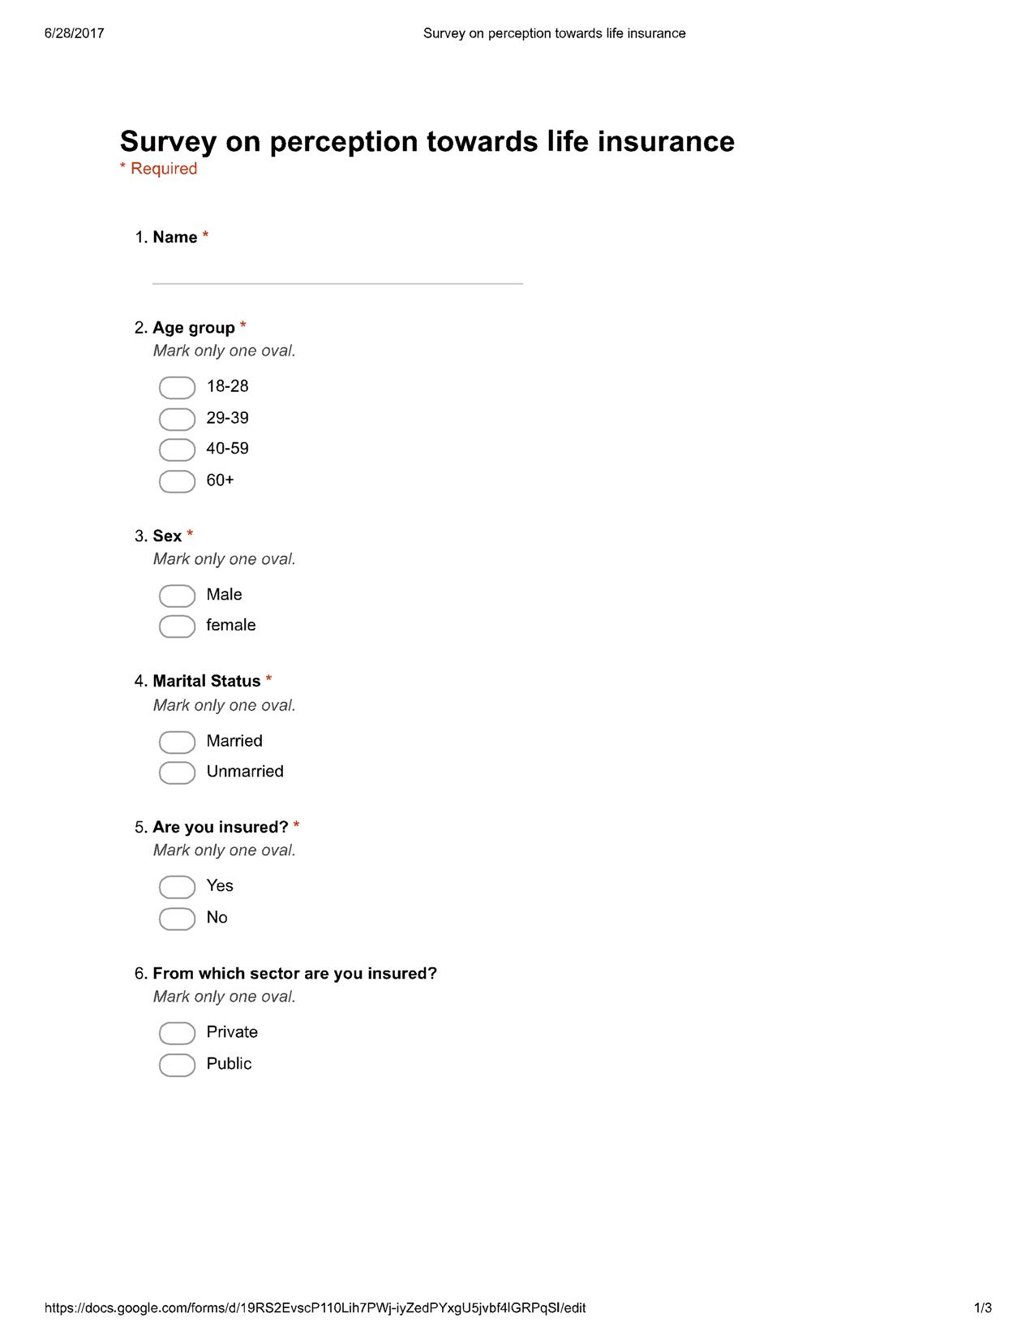

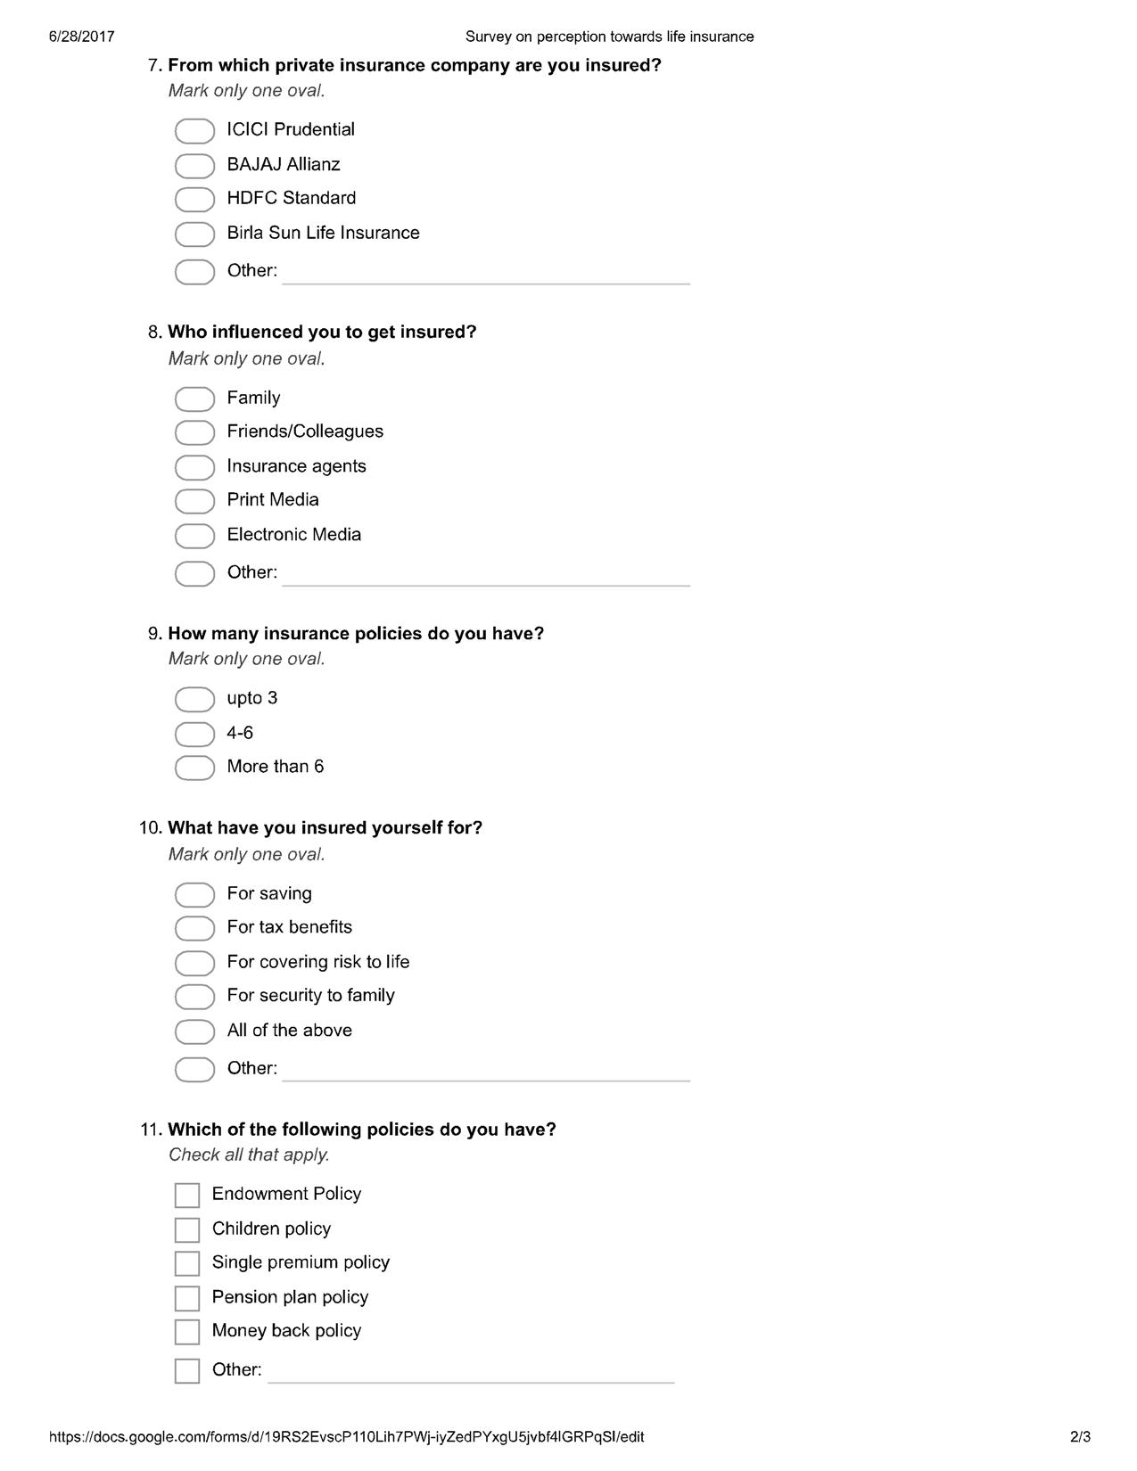

## RESULTS AND FINDINGS

Top of Form

### C:\Users\User\AppData\Local\Temp\msohtmlclip1\01\clip_image001.jpg

### C:\Users\User\AppData\Local\Temp\msohtmlclip1\01\clip_image001.jpg

### C:\Users\User\AppData\Local\Temp\msohtmlclip1\01\clip_image001.jpg

### C:\Users\User\AppData\Local\Temp\msohtmlclip1\01\clip_image001.jpg

# CHAPTER 4: CONCLUSION

## 4.1 Summary

### One of the major learning for me in this internship, the objective of joining Birla Sun Life Insurance, was to get an exposure to the corporate world, to be precise in the Life Insurance sector, Media and Marketing.

### For the success of any sector, its media and marketing planning plays an important part. The following mediums were used to promote the brand and the products of the company – TVCs, Print Ad, Hoardings/Billboards, and Social media. No company can survive using only a particular medium of marketing. It needs to be a mix of both online as well as offline strategies.

### I also got chance to interact with the students from different B-schools. It was interesting to understand their approach towards a problem and their solving skills in the best possible manner. An important learning was the execution of the strategy. It is important that the strategy which is planned is properly executed. There are many factors that may cause failure of execution, hence it is important to ensure proper implementation of strategy.

## 4.2 Gains Of The Study

This project is going to help the company for promotion of Birla sun life. There will be higher reach of audience and it will be easy to convert suspect into prospect. There will be higher trust for its product and more number of sale.

## 4.3 Limitations of the Project

### Since the project had to be completed within a stipulated period time, the information collected cannot be generalized to all the customers.

### The research was only limited to the marketing strategies of the company, so couldn’t study the overall functioning of the company.

# 

# Chapter 5: RECOMMENDATIONS AND LEARNINGS

* Birla should target the customers better and provide leads to the interns for better conversion.
* Birla Sun Life should provide a minimum stipend to motivate the interns.
* As witnessed in Key Findings, Birla Sun Life Insurance needs to work on their Social Media Marketing strategy, which includes increasing customer interaction on Facebook, daily or weekly updates on twitter which also involves “hashtags” in accordance with CSR campaign. Social Media Marketing in today’s world is the most cost effective solution for customer engagement. Taking small but immediate steps in social media marketing will gradually benefit the company in the long run.
* This can be done by finding content that resonates with followers/fans, making sure that the content is accessible on mobile devices, posting photos and videos as related or unrelated posts, offering contests or sweepstakes, posting clever questions to engage your followers, responding to each and every comment made by the followers be it a relevant query or not, posting info graphics that followers will appreciate and including a little humour also goes a long way.
* The current scenario of Life Insurance market is that majority of target segment are people from urban areas but India constitutes of approximately 70% of rural population. LIC has been paving ways in the rural market with an overall 50% of market share in India by introducing flexible plans for people living in the rural areas. This combined with their huge network of agents has allowed them to penetrate into the rural market.

Amalgamation of “Sustainable Skill development” with flexible insurance plans and having a huge backing of Aditya Birla Conglomerate can be a start for Birla Sun Life Insurance to compete with existing players toe to toe.

* The trend of theme of TVCs in insurance industry is mostly “emotional”. In this report, we made an attempt to create commercials, which aren’t so emotional and received a fairly good response from the respondents, which suggests that different concepts can be used for Insurance commercial.
* Though the resources of Interactive Advertisement in India are scarce, but with the advent of such Advertisements can create a long lasting sense of belongingness with the customers and customers in turn propagate such innovative Advertisement campaigns through social media and other medium.

**LEARNINGS**

* I am now more familiar about insurance sector and its relevant terms.
* I came to know about Birla Sun life’s products like Child plan, retirement plan, tax plan etc.
* By brainstorming different ideas with the group members, I acquired knowledge of different sectors as well.
* I came to know about importance of each Quarter and how to plan activities for that quarter.
* I came to know about different statistical analysis and numbers of activities with their importance.
* Learned how to pitch the customers for sale.
* Learned to do the tasks before the given time.
* Learned how to deal with the customers.
* Learned to prepared a questionnaire and how to take survey.

# REFERENCES

* http://www.thehindu.com/business/Industry/govt-allows-49-fdi-in-insurance-under-automatic-route/article8375048.ece (March 19,2016)
* http://www.birlaSun Life.com/
* <http://www.ibef.org/industry/insurance-sector-india.aspx>
* <http://www.canarahsbclife.com/pdf/ficci-choice-insurance-report-final.pdf>
* <http://iosrjournals.org/iosr-jbm/papers/vol3-issue5/D0351727.pdf>
* <http://timesofindia.indiatimes.com/life-style/health-fitness/70m-diabetics-in-India-by-2015-Study/articleshow/4836201.cms>
* <http://food.ndtv.com/health/world-heart-day-2015-heart-disease-in-india-is-a-growing-concern-ansari-1224160>
* <http://maximizesocialbusiness.com/engage-your-audience-social-media-today-8240/>
* <http://www.thehindu.com/business/Industry/govt-allows-49-fdi-in-insurance-under-automatic-route/article8375048.ece>
* Philip Kotler (2012) Marketing Management: A South Asian Perspective
* Chawla, Deepak, & Sondhi Neena (2011) Research Methodology Concepts and Cases (Pearson Publication)